Belvoir Elementary School

Is the place we can succeed.

There the teachers care for us and

Help us all to achieve.

Reading, Writing, Math, and Science,

Art and Music and P.E.

Belvoir Elementary School where

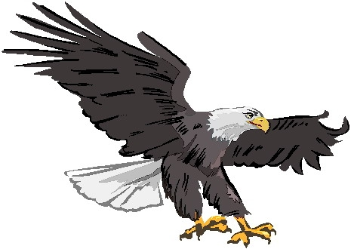
EAGLES SOAR HIGH and FREE!

